Jackson Heart Study Neighborhood Survey Data

- Overview of Neighborhood Survey Data

Jackson Heart Study (JHS) conducted a survey on the neighborhood conditions of the JHS participants. JHS participants were asked some questions about their neighborhood where they live that includes places where they shop, attend church, access a park, or visit neighbors. There were a total of 4538 JHS participants who completed the survey between 2004 and 2010. The JHS participants were asked to rate their neighborhood conditions on a 4-point Likert scale via a questionnaire. The questions include a total of 17 items (Table 1) which asked the participants to rate the conditions of their neighborhood on issues related to social cohesion (A=Strongly agree to D=Strongly disagree), exposure to violence (O=Often to N =Never) and neighborhood problem measures (V= Very serious problem to N= Not really a problem).

Table 1: Items used in JHS to assess neighborhood conditions.

Items | Description | Code
 |  | 1 =Strongly Disagree (D) to 4=Strongly Agree (A)
AF3V13 | This is a close knit neighborhood
AF3V14 | People around here are willing to help their neighbors
AF3V15 | People in this neighborhood generally don't get along (REVERSE CODED)
AF3V16 | People in this neighborhood can be trusted
AF3V17 | People in this neighborhood do not share the same values (REVERSE CODED)
AF3V18 | This neighborhood is safe from crime
 |  | 1=Never (N) to 4 =Often (O)
AF3V19 | How often was there a fight in this neighborhood in which a weapon was used
AF3V20 | How often was there a violent argument between neighbors
AF3V21 | How often were there gang fights?
AF3V22 | How often was there a sexual assault or rape?
AF3V23 | How often was there a robbery or mugging?
 |  | 1= Not really a problem (N), 4=Very serious problem (V).
AF3V24 | Excessive noise
AF3V25 | Heavy traffic or speeding cars
AF3V26 | Lack of access to adequate food and/or shopping
AF3V27 | Lack of parks and playground
AF3V28 | Trash and Litter
AF3V29 | No sidewalks and poorly maintained sidewalks

The time period for the JHS neighborhood survey data collection was supposed to correspond to Annual follow-up (AFU) Year 3, instead the neighborhood survey data was continuously collected from 2004 to 2010. In addition, JHS did not collect the exact address information at the time when the neighborhood survey was conducted. Furthermore, it is not possible to link the neighborhood survey directly to the clinic visit 1 (Exam 1) and visit 2 (Exam 2) because the dates of collection of the neighborhood survey do not correspond with the dates for clinic visit 1 and 2. Clinic visit 1 was conducted from Sept 2000 to Mar 2004 while clinic visit 2 was conducted from Oct 2005 to Dec 2008 (See Appendix A for the timeline of the different JHS exams and environmental measures). In order to identify the residential addresses of the participants at the time of completion of their neighborhood survey, address matching of the neighborhood survey with the clinic visits or AFU was conducted. We assigned geocoded addresses from clinic visits or AFU by matching the dates of collection of neighborhood survey to the closest (nearest) dates of clinic visits or AFU available. Thus, a dataset was created with date of collection of neighborhood survey, date of closest (nearest) clinic visits or AFU and corresponding geocoded address (for more information on geocoding documentation, please refer JHS address geocoding documentation. The SAS file for the geocoded survey data is located under the folder “U:\EPID\CIAHD\JHS Data\Environmental Assessment Core\data\Neighborhood data\eb_estimates\ survey_address.sas7bdat”. This dataset was then used to create neighborhood environment scores.
Although our objective was to create time varying neighborhood scores for the different exam periods (Exam 1 and Exam 2), when we looked at the distribution of the date of collection for the neighborhood survey by years we found that the data were too sparse to create different scores for the different exam periods (Table 2). The majority of the neighborhood survey data were clustered (collected) within the 5 years period, i.e., between 2004 and 2008 as shown in Table 2. In order to obtain a more reliable neighborhood scores at census tract level, we pooled the survey data that was collected for the 5 years (2004-2008) and created only one neighborhood score for each census tract. Therefore, the neighborhood survey scores are time-invariant, which means we cannot study change in neighborhood characteristics (aside from changes resulting from residential moves, as these participants will have two or more different neighborhood scores). For all calculations of JHS neighborhood scores, we used census tract 2000 boundaries as the proxy for neighborhood.

Table 2: Distribution of date of collection of JHS neighborhood survey by year

Years | % Percent
2004 | 690 (15.11)
2005 | 941 (20.60)
2006 | 1194 (26.14)
2007 | 1139 (24.94)
2008 | 473 (10.36)
2009 | 98 (2.15)
2010 | 3 (0.07)

- Identifying neighborhood scales

First, we cleaned the original survey variables. We recoded unknown or missing values (e.g.,K= “Don’t Know” or R= “Refused” to missing), and recoded the 4-point Likert scale from string values to numeric values of 1 to 4. For items AF3V13- AF3V18 , response to strongly agree (A) was coded as 4, Agree (B) was assigned as 3, disagree (C) was assigned as 2 and strongly disagree (D) was assigned a score 1. In addition, for two of the questions (AF3V15 and AF3V17), we reversed the codes so the questions followed the same direction as other items in the scale. For items AF3V19- AF3V23, response to often (O) is coded as 4, sometimes (S) was assigned as 3, rarely (R ) was coded as 2, and Never (N) was assigned a score 1. For items AF3V24- AF3V29, response to very serious problem (V) is coded as 4, somewhat serious problem (S) was assigned as 3, minor problem (M) was coded as 2, and not really a problem (N) was assigned a score 1. The processed raw neighborhood survey data in wide format with 1 row per participant (“jhs_scales_wide.sas7bdat”) and long format with 1 row per question per person for multiple rows per person (“jhs_scales_long.sas7bdat”) are available under the folder: “U:\EPID\CIAHD\JHS Data\Environmental Assessment Core\data\Neighborhood data\eb_estimates\ (see Appendix B for a list of datasets raw dataset and Empirical Bayes estimates datasets).
Next, we performed principal component analysis (PCA) with promax oblique rotation, and factor analysis (FA) with maximum likelihood on the 17 items of JHS neighborhood survey to identify the underlying neighborhood scales. The PCA with promax oblique rotation identified three neighborhood scales. A factor loading >=0.4 and unambiguous loading on a single factor was used as a criteria for item retention. Thus, items that loaded highly on one scale (>= 0.40) were retained while items with low factor loadings (< 0.4) were excluded. Of the items, only the safety item (AF3V18- this neighborhood is safe from crime) was excluded because of low loadings. The three neighborhood scales identified by PCA include social cohesion, violence, and neighborhood problems (Table 3 and Appendix D1). The scales identified by PCA were assessed for validity and internal consistency using Cronbach’s alpha. Items within each neighborhood scale had good internal consistency (Table 4), with Cronbach’s alpha ranging from 0.76-0.80.
In contrast, the FA yielded four scales including social cohesion, violence, neighborhood disorder, and neighborhood problem (Table 3 and Appendix D2). The Cronbach’s alpha shows that while the social cohesion and violence scales have similar alphas to the PCA method, the FA-based neighborhood resources and the neighborhood disorder scales have slightly lower alphas. Cronbach’s alphas for the FA-based scales range from 0.61-0.78 (Table 4). There are some additional differences between the two methods. For example, while the PCA identified one neighborhood problem scale with 6 items, the FA broke the scale into neighborhood resources and disorder with three items in each. In addition, while the safety item loaded with the FA-based social cohesion scale, it did not load on any of the PCA-based scales. Similarly, while item Viol22 (AF3V22) “How often was there a sexual assault or rape?” loaded with PCA-based violence scale, it did not load on the FA-based violence scale.
The differences between the scales derived from FA and PCA, while minor, may have theoretical or quantitative implications on your analysis. Neither is necessarily better than the other, but your hypothesis and theory should drive your choice of method, or you might consider trying both methods. It is also possible, that while the items that did not load well onto the factors using FA (but that had good loadings using PCA) make sense theoretically overall (e.g. “People in this neighborhood do not share the same values” makes sense as an indicator of social cohesion), in our data these items may not be measuring what we expect they should measure. Therefore, both PCA and FA-based scales were used in calculating neighborhood scores for the Jackson Heart Study.

Table 3: Comparison of neighborhood scales using PCA vs. factor-based methods
PCA-based Scales | FA-based Scales
Neighborhood Social Cohesion | Neighborhood Social Cohesion
1. AF3V13: This is a close knit neighborhood | 1. AF3V13: This is a close knit neighborhood
2. AF3V14: People around here are willing to help their neighbors | 2. AF3V14: People around here are willing to help their neighbors
3. AF3V15: People in this neighborhood generally don't get along (REVERSE CODED) | 3. AF3V15: People in this neighborhood generally don't get along (REVERSE CODED)
4. AF3V16: People in this neighborhood can be trusted | 4. AF3V16: People in this neighborhood can be trusted
5. AF3V17: People in this neighborhood do not share the same values (REVERSE CODED) | 5. AF3V18: This neighborhood is safe from crime
Neighborhood violence | Neighborhood violence
1. AF3V19: How often was there a fight in this neighborhood in which a weapon was used | 1. AF3V19: How often was there a fight in this neighborhood in which a weapon was used
2. AF3V20: How often was there a violent argument between neighbors | 2. AF3V20: How often was there a violent argument between neighbors
3. AF3V21: How often were there gang fights? | 3. AF3V21: How often were there gang fights?
4. AF3V22: How often was there a sexual assault or rape?
5. AF3V23: How often was there a robbery or mugging? | 4. AF3V23: How often was there a robbery or mugging?
Neighborhood Problems | Neighborhood Disorder
1. AF3V24: Excessive noise | 1. AF3V24: Excessive noise
2. AF3V25: Heavy traffic or speeding cars | 2. AF3V25: Heavy traffic or speeding cars
4. AF3V26: Lack of access to adequate food and/or shopping | 3. AF3V28: Trash and Litter
5. AF3V27: Lack of parks and playground | Neighborhood Resources
3. AF3V28: Trash and Litter | 4. AF3V26: Lack of access to adequate food and/or shopping
6. AF3V29: No sidewalks and poorly maintained sidewalks | 5. AF3V27: Lack of parks and playground
 | 6. AF3V29: No sidewalks and poorly maintained sidewalks

Table 4: Descriptive statistics of neighborhood scales for the Jackson Heart Study
Scales | No. of obs | No. of subjects | No. of tracts | Median N per tract | No of tracts w/ 1 subject | No Items in scale | Range of scores | Mean score | SD | Cronbach's alpha
PCA method
Social cohesion | 20755 | 4339 | 165 | 10 | 56 | 5 | 1-4 | 3.02 | 0.83 | 0.77
Violence | 20074 | 4252 | 164 | 10 | 54 | 5 | 1-4 | 1.24 | 0.62 | 0.80
Problem | 26121 | 4374 | 166 | 10 | 63 | 6 | 1-4 | 1.54 | 0.93 | 0.76
FA method
Social Cohesion | 20943 | 4347 | 165 | 10 | 62 | 5 | 1-4 | 2.99 | 0.83 | 0.77
Violence | 16062 | 4244 | 164 | 10 | 61 | 4 | 1-4 | 1.28 | 0.67 | 0.78
Disorder | 13090 | 4374 | 166 | 10 | 63 | 3 | 1-4 | 1.66 | 0.95 | 0.74
Resources | 13031 | 4244 | 165 | 10 | 63 | 3 | 1-4 | 1.43 | 0.90 | 0.61

- Multilevel Regression models

Before we calculated the empirical Bayes estimates, we initially ran four different models to explore variations in response to perceived neighborhood conditions by demographic variables (age and gender) and to examine the validity socioeconomic status (SES) as predictors of JHS neighborhood conditions. Information on SES indicators at census tract level for the JHS study area was obtained from the 2000 U.S census. Based on factor analyses of 19 variables representing the dimensions of racial/ethnic composition, family structure, housing, area crowding, residential stability, education, employment, occupation, and income/wealth, we identified two factors that accounted for 83% of the variance. These two factors (factor 1: % vacant housing, % houses without a telephone, % of houses without a vehicle, % unemployed individuals, % poverty, median household income; factor2: % with at least a bachelors degree, %non-managerial occupation, % of households with interest, dividends, or net rental income).
The first model (Model 1) was an unadjusted model. Model 2 was adjusted for demographic variables (age and gender). Model 3 was additionally adjusted for neighborhood SES indicators (factor 1 and factor 2). Finally, Model 4 adjusts for age and gender but also accounts for spatial dependencies. While models 1-3 were run as 3-level hierarchical regression models with the items of each neighborhood scales as an outcome (i.e., scale items nested within individuals nested within neighborhoods (census tracts), model 4 was run as a 2-level spatial multilevel model with the individual’s crude mean for each scale as the outcome (i.e., individual’s crude mean score nested within census tracts). All models were run using HLM 7 software (see Appendix G for steps in running the models in HLM).
The results (Appendix E, Tables E1 & E2) indicate that age was significantly associated with each of the neighborhood scales. For example, older participants were significantly more likely to reporter better social cohesion and less violence and neighborhood problems. Gender was also statistically significant with the social cohesion scale for FA-based methods and neighborhood problems scale for both PCA and FA based methods. This suggests that when calculating empirical Bayes estimates, age and gender should be used as adjustments in the models. The results also showed that factor 1 was strongly and negatively associated with social cohesion while positively associated with violence, neighborhood problems and disorder as expected. Factor 2 was also significantly associated with two FA-based neighborhood disorder and neighborhood resources scales. This suggests that factor 1 and factor 2 can be used as predictors of when computing conditional empirical Bayes estimates because they are good indicators of JHS neighborhood conditions.

- Variance components and intra-neighborhood correlation coefficient (ICC) of the Jackson Heart Study neighborhood scales

Tables 5a & b provide summary results of the variance components, reliabilities and intra-neighborhood correlation (ICC) for each scale type and model. The results indicated that the neighborhood reliabilities range from 0.562 (neighborhood resources) to 0.757 (violence). However, the reliabilities for PCA based scales were higher compared to the FA-based scales. The intra-neighborhood correlation coefficient (ICC) ranges from 0.092 (social cohesion) to 0.201 (disorder). In general, the spatial correlation parameter for all of the scales was positive and greater > 0.80, indicating that a census tract with high (low) score of neighborhood scale tends to be surrounded by other similarly high (low) scores of census tracts.

Table 5a: Variance components, intra-neighborhood correlation coefficient (ICC) and reliabilities for the PCA based neighborhood scales of the Jackson Heart Study
Variance Components | Model 1 | Model 2 | Model 3 | Model 4
Social cohesion PCA
Within-person variance | 0.438 | 0.438 | 0.438
Within-neighborhood variance | 0.237 | 0.235 | 0.235 | 0.313
Between-neighborhood variance | 0.024 | 0.025 | 0.013 | 0.009
Intra-neighborhood correlation (ICC) | 0.092
Reliability | 0.717 | 0.716 | 0.715
†Average Level-2 Variance |  |  |  | 0.026
‡ρ |  |  |  | 0.847
Violence PCA
Within-person variance | 0.223 | 0.223 | 0.223
Within-neighborhood variance | 0.154 | 0.149 | 0.148 | 0.152
Between-neighborhood variance | 0.021 | 0.027 | 0.006 | 0.004
Intra-neighborhood correlation (ICC) | 0.120
Reliability | 0.757 | 0.751 | 0.751
†Average Level-2 Variance |  |  |  | 0.017
‡ρ |  |  |  | 0.894
Problem PCA
Within-person variance | 0.586 | 0.586 | 0.586
Within-neighborhood variance | 0.246 | 0.245 | 0.245 | 0.342
Between-neighborhood variance | 0.053 | 0.055 | 0.006 | 0.011
Intra-neighborhood correlation (ICC) | 0.177
Reliability | 0.715 | 0.714 | 0.714
†Average Level-2 Variance |  |  |  | 0.053
‡ρ |  |  |  | 0.907
*Model 1 = unadjusted model
*Model 2 = adjusted for age (grand centered) and gender (grand centered);
*Model 3 = adjusted for age (grand centered), gender (grand centered), factor 1 (grand centered) and factor2 (grand centered);
*Model 4 = spatial model adjusted for age (grand centered) and gender (grand centered))
‡ρ (rho) = spatial correlation parameter indicating with zero indicting no spatial dependence and positive or negative values indicating whether a neighborhood is surrounded by other neighborhoods with similar or different values on outcome.
†Average Level-2 Variance is the average of neighborhood specific-variance.
Intra-neighborhood correlations (ICC) were calculated using intercept model (model 1). The formula used to calculate the ICC is:
ICC = tb/(tb+tp)
Where
tb = between neighborhood variance
tp = within neighborhood variance

Table 5b: Variance components, intra-neighborhood correlation coefficient (ICC) and reliabilities for the FA based neighborhood scales of the Jackson Heart Study
Variance Components | Model 1 | Model 2 | Model 3 | Model 4
Social cohesion FA
Within-person variance | 0.450 | 0.450 | 0.450
Within-neighborhood variance | 0.215 | 0.211 | 0.211 | 0.292
Between-neighborhood variance | 0.029 | 0.033 | 0.014 | 0.010
Intra-neighborhood correlation (ICC) | 0.119
Reliability | 0.694 | 0.689 | 0.690
†Average Level-2 Variance |  |  |  | 0.031
‡ρ |  |  |  | 0.863
Violence FA
Within-person variance | 0.239 | 0.239 | 0.239
Within-neighborhood variance | 0.196 | 0.190 | 0.190 | 0.211
Between-neighborhood variance | 0.029 | 0.036 | 0.007 | 0.007
Intra-neighborhood correlation (ICC) | 0.129
Reliability | 0.749 | 0.743 | 0.743
†Average Level-2 Variance |  |  |  | 0.026
‡ρ |  |  |  | 0.880
Disorder FA
Within-person variance | 0.496 | 0.496 | 0.496
Within-neighborhood variance | 0.349 | 0.348 | 0.349 | 0.515
Between-neighborhood variance | 0.088 | 0.090 | 0.015 | 0.020
Intra-neighborhood correlation (ICC) | 0.201
Reliability | 0.678 | 0.678 | 0.678
†Average Level-2 Variance |  |  |  | 0.086
‡ρ |  |  |  | 0.895
Resources FA
Within-person variance | 0.548 | 0.548 | 0.548
Within-neighborhood variance | 0.236 | 0.233 | 0.233 | 0.342
Between-neighborhood variance | 0.029 | 0.031 | 0.004 | 0.011
Intra-neighborhood correlation (ICC) | 0.109
Reliability | 0.562 | 0.559 | 0.559
†Average Level-2 Variance |  |  |  | 0.053
‡ρ |  |  |  | 0.907
*Model 1 = unadjusted model
*Model 2 = adjusted for age (grand centered) and gender (grand centered);
*Model 3 = adjusted for age (grand centered), gender (grand centered), % of black (grand centered) and Poverty (grand centered);
*Model 4: spatial model adjusted for age (grand centered) and gender (grand centered))
‡ρ (rho) = spatial correlation parameter indicating with zero indicting no spatial dependence and positive or negative values indicating whether a neighborhood is surrounded by other neighborhoods with similar or different values on outcome.
†Average Level-2 Variance is the average of neighborhood specific-variance.

Calculating Neighborhood Scores at Census tract levels.

We calculated crude means and three different versions of empirical Bayes estimates (unconditional, conditional, and spatial) for each neighborhood scale at the census tract level. We used Hierarchical Linear Modeling (HLM) Software Version 7 to calculate the three versions of empirical Bayes estimates. The files for the crude means (“jhsnb_crude_mean.sas7bdat”) and the empirical Bayes estimates for the PCA-based (“jhsnb_eb_ests_pca.sas7bdat”) and FA-based neighborhood scales (“jhsnb_eb_ests_fa.sas7bdat”). See also Appendix B for the location of crude means and empirical Bayes estimates datasets. Included in the same folder also data dictionary for these estimates (Neighborhood Survey EB Estimates_ dictionary_011813.doc, which is also included in Appendix C2) and a summary of the variables from PROC CONTENT (“Neighborhood Survey EB Estimates_Proccontents_011813.rtf”) as well as SAS and R codes used for preparing the datasets and calculating the estimates (creating_jhs_nb_empirical_estimates_121612.sas, jhs_nbscales_datasetup_082312.sas).
.
A summary review of the estimates and how they were calculated in HLM is presented below. For additional information on the different versions of empirical Bayes estimates, please refer to (Mujahid eta l. 2006, Mujahid et al. 2008, Verbitsky-Savit and Raudenbush 2009).

Crude Means

The crude means for each neighborhood scale for both PCA and FA based methods at the census tract level were calculated by taking the sum of the responses to all questions in a given dimension and dividing by the number of questions (i.e., the individual’s average across the questions in that scale). The mean was calculated only if the participant answered all questions in the scale. If they did not answer all questions, this mean will be missing for the individual. These individual means were then aggregated at the census tract level and the final crude mean is the mean of all the individual means of participants living within that census tract. These were calculated using SAS 9.2 proc means by census tract. However, since crude means may be unreliable due to small sample size of participants within a census tract, we also calculated 3 different versions of empirical Bayes estimates (unconditional, conditional, and spatial) to improve the reliability of each neighborhood scale.

Calculating Empirical Bayes Estimates

We calculated four different versions of empirical Bayes estimates for the JHS neighborhood survey at the census tract level. The first estimate was unadjusted unconditional empirical Bayes estimates (UEBE). The second estimate was age (grand mean centered) and gender (grand mean centered) adjusted unconditional empirical Bayes estimates (UEBE). Note that there is subtle difference between unadjusted and age & gender adjusted UEBE. They are both unconditional estimates since both are not conditioned on the predictors of level three variables. However, the later estimate adjusts for variations in response to perceived neighborhood conditions by age and gender of the JHS participants. Each estimate is adjusted to the overall age and gender distribution of the sample, so that systematic differences in reporting by age or gender (which may differ in their distribution across tracts) do not affect estimates. Originally, we calculated the age and gender adjusted UEBE, but later we added the unadjusted UEBE to be consistent with MESA study. Both estimates are highly correlated (see document on Lin’s concordance plot and Pearson’s correlation coefficients lin_concordance_pca.rtf & lin_concordance_fa.rtf) The third estimate was the conditional empirical Bayes estimates (CEBE); in additional to adjusting for age (grand mean centered) and gender (grand mean centered), this estimate also is conditioned on the SES indicators (factor 1 and factor 2), ie it uses information on SES characteristics of the census tract to “improve” the estimate for a specific tract based on the relation between tract SES and the survey measures observed across the whole sample.. The fourth estimate was the spatial empirical Bayes estimate, which also adjusted for age (grand mean centered), gender (grand mean centered) and additionally accounts for spatial dependence in the survey data survey type (grand mean centered), The unconditional and conditional empirical Bayes estimates were implemented under 3-level multilevel modeling framework i.e., items are nested within persons, in turn persons are nested within neighborhoods (census tract) while the spatial empirical Bayes estimates were implemented under 2-level multilevel modeling framework where the individual raw mean score is nested within census tract. All these estimates were calculated using Hierarchical Linear Modeling (HLM) Software version 7 (see Appendix E for the steps in HLM). These estimates were also run in SAS 9.2 using Proc HPMIXED to compare the results between statistical packages.

The level 1 model:
Y_{ijk} = b_{ojk} + e_{ijk ,} represents the ith response item for the jth person in the kth neighborhood as a function of the person-specific mean score across all items corresponding to a neighborhood dimension (b_{ojk}), and an error term (e_{ijk}) that is normally distributed with a mean 0 and variance σ².

The level 2 model:
b_{0jk}=β_{00k}+ β_{01k} + β_{02k} + α_{0jk} models the person-specific mean score for a person j in neighborhood k as a function of the neighborhood specific mean (β_{00k}) , age (β_{01k}), gender (β_{02k}), and a random effect for person j in neighborhood k (α_{0jk}), which is normally distributed with mean 0 and variance τ_{b}.

The level 3 model:
β_{00k}=γ₀₀₀+U_{00k,} models the neighborhood specific mean score for neighborhood k as a function of the overall mean score (γ₀₀₀) and a random effect for neighborhood k (U_{00k}) that is normally distributed with mean 0 and variance τ_{η}²⁴.

Unconditional Empirical Bayes Estimate
The unconditional empirical Bayes estimate (UEBE) is a weighted average of the crude mean for each neighborhood k and the crude mean across all neighborhoods in the study. The weights are proportional to the reliability of the neighborhood measure. The unconditional empirical Bayes estimate is expressed as:

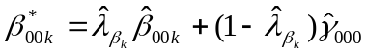

where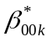 is the unconditional EB estimate of the mean scale score for neighborhood K for a particular neighborhood dimension
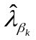is the estimated reliability of the neighborhood level measure
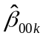 is the model estimated crude mean for neighborhood k
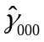 is the estimated mean scale score pooled across neighborhoods ³⁵ .

The reliability is estimated by
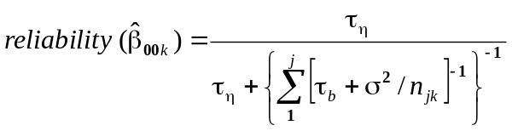

Conditional empirical Bayes estimate

The conditional empirical Bayes estimate (CEBE) is derived similarly to the UEBE estimate. The difference is reflected in the level 3 model, which includes measures of neighborhood SEP in the estimation of the neighborhood specific means scale score. Consequently, the conditional estimator pulls less reliable neighborhoods towards the mean of similar neighborhoods instead of towards the mean across all neighborhoods in the study population. For JHS neighborhoods, similar neighborhoods are defined as those neighborhoods that have comparable socioeconomic profiles using census derived indicators of neighborhood SEP across various dimensions. Information on SEP indicators of neighborhoods (census tracts) was obtained from the 2000 U.S census. Based on factor analyses of 19 variables representing the dimensions of racial/ethnic composition, family structure, housing, area crowding, residential stability, education, employment, occupation, and income/wealth, we identified two factors that accounted for 83% of the variance. These two factors (factor 1: % vacant housing, % houses without a telephone, % of houses without a vehicle, % unemployed individuals, % poverty, median household income; factor2: % with at least a bachelor’s degree, %non-managerial occupation, % of households with interest, dividends, or net rental income) were included as predictors in the conditional EB estimation. For details about how these two factors are developed by Mahasin Mujahid, please refer to paper by Mahasin Mujahid, 2008 (Relation between neighborhood environments and obesity in the Multi-Ethnic Study of Atherosclerosis. American journal of epidemiology, 2008. 167(11): p. 1349-57). The conditional empirical Bayes is expressed as:

where,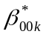 is the conditional EB estimate for neighborhood k for a particular neighborhood dimension
is the estimated reliability of the neighborhood level measure
is model estimated crude mean for neighborhood k
is the estimated grand neighborhood mean, when the neighborhood-level covariates W_{k1} and
W_{k2} are 0
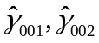 are the parameter estimates for neighborhood SES factor scores
W_{k1,} W_{k2} are census derived measure of neighborhood SES.

Spatial empirical Bayes estimate

In addition to the clustering effect, survey data can have spatial dependence induced by contiguity or spatial proximity in neighborhood locations (census tracts). In such settings, spatial empirical Bayes estimate (SEBE) can provide a more precise and reliable estimate by accommodating spatial dependence (Verbitsky Savitz and Raudenbush 2009). Recently, Raudenbush eta l. (2011) developed spatial dependence option under HLM2 (HLM version 7) that allow researchers handle nested data collected in spatial settings. SEBE is a weighted mean of the crude mean for each neighborhood and the mean of the surrounding neighborhoods. Surrounding neighborhoods are defined as those surrounding census tracts that share common borders or vertices with a particular census tract. Therefore, unlike unconditional and conditional empirical Bayes estimates, it generates estimates by taking into account the spatial dependence in data and “shrinks” unreliable neighborhoods toward the mean of the surrounding neighborhoods.
The steps for calculating the spatial empirical Bayes estimate is somewhat different from the unconditional and conditional empirical Bayes estimates because the spatial dependence option is only available at two-level (HLM2) option. Therefore, under the two-level multilevel model, the person-specific mean score (Y_{jk}) can be modeled separately at the level 1 and level 2 models.

The level 1 model:
Y_{jk}=β_{0k}+ β_{1k} + β_{2k} + e_{jk} models the person-specific mean score for a person j in neighborhood k as a function of the neighborhood specific mean (β_{0k}) , age (β_{1k}), gender (β_{2k}), the random effect for person j in neighborhood k, and an error term (e_{jk}) that is normally distributed with a mean 0 and variance σ².

The level 2 model:
β_{0k}=γ₀₀+b_{0k} models the neighborhood specific mean score for neighborhood k as a function of the overall mean score (γ₀₀) and a random effect for neighborhood k (b_{0k}) that is normally distributed with mean 0 and variance τ_{η}²⁴.

The spatial dependence model:
In the spatial dependence model we account for spatial dependence as follows.
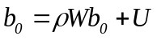
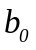 is level 2 random spatially autoregressive effects
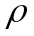 is a scalar spatial parameter.

Where is a scalar spatial parameter. > 0 indicates that a site is typically surrounded by other sites with similar values on the outcome. Thus, a site with a high value of the outcome tends to be surrounded by other similarly high outcome-valued sites, and a site with a low value is typically surrounded by other low outcome-valued sites. On the other hand, < 0 indicates that high-value sites are typically surrounded by low-value sites, and vice versa. Finally, ρ = 0 indicates no spatial dependence.
 is the spatial weight matrix used in the analysis based on adjacency of the census tracts. In the simplest case, W is a binary contiguity matrix (or a row-standardized binary contiguity matrix) indicating that sites are contiguous to each other. In this paper, we used the row-standardized binary contiguity matrix where nonzero entries are used for neighborhoods that share a common boundary (i.e., “rook” criterion). Specifically, set 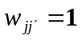 if neighborhood j is contiguous to neighborhood j, and 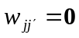 if not. 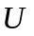 is the level-2 error that is normally distributed with mean 0 and variance τ_{k}.

- Assessment of agreements between different methods

Tables E1&E2 (Appendix E) summarize the results of the Pearson correlation Coefficients (r) and Concordance Correlation Coefficients (CCC) for PCA and FA based neighborhood scales among the crude mean and the three empirical Bayes estimates ( unconditional, conditional, and spatial). CCC is a measure of agreement between two variables and correspondence within groups (i.e., how strongly do scores within the same neighborhood (census tract) resemble each other?) (Lin 1989). Neighborhood estimates with the highest CCC and correlation coefficient have the best agreement.

We found weak agreement between crude mean (simple mean) and the three empirical Bayes estimates models (Appendix E). The lowest agreement was found in the FA-based neighborhood resource scale between crude mean and SEBE (r = 0.415 and CCC= 0.227 (0.153, 0.302) and the highest agreement was found in the PCA-based neighborhood problem between crude mean and UEBE (r=0.743, CCC=0.525 (0.463, 0.588)). Comparison of the agreements between the three empirical estimates (unconditional, conditional and spatial) show overall high agreement between UEBE (unconditional) and SEBE (spatial) compared to CEBE (Conditional) for most of the scales. In general, our suggestion is to use the empirical Bayes estimates for analyses rather than the crude mean. The numerous census tracts with only 1 person, leads to substantial noise and unreliable estimates. In addition, we recommend using either the unconditional empirical Bayes estimate (UEBE) or spatial empirical Bayes estimate (SEBE) for analysis purposes.

- APPENDIX

APPENDIX A: Timeline for different neighborhood domains of the Jackson Heart Study

Year | 2000 | 2001 | 2002 | 2003 | 2004 | 2005 | 2006 | 2007 | 2008 | 2009 |  | 2010 | 2011 | 2012
Exams | Exam 1 (Sept 2000 - Mar 2004) |  |  |  |  | Exam 2 (Oct 2005 - Dec 2008) |  |  |  | Exam 3 (Feb 2009 - May 2012)
Geocoding data | Baseline (visit 1) geocode address |  |  |  |  | Visit 2 geocode matched from Annual Follow Up address |  |  |  |  | Exam 3 ( pending)
Neighborhood Survey data |  |  |  |  | 2004 – 2008 (the same scores for Exams 1 & 2), but differ for those who moved.
Food Stores data | NETS data (1999-2010), TD/Nielsen (2000-2011)
Recreational Facilities | NETS data (2000-2011)
Built Environment data | In progress
Census-based Socioeconomic data | Census 2000 |  |  |  |  | ACS (2005-2009) |  |  |  |  |  | Census 2010

Appendix B: List of Neighborhood Survey EB estimate datasets created
Dataset | Location | Type | Description
jhs_scales_wide.sas7bdat | U:\EPID\CIAHD\JHS Data\Environmental Assessment Core\data\Neighborhood data\eb_estimates | Neighborhood Survey dataset | Raw JHS neighborhood items in wide format with 1 row per participant
jhs_scales_long.sas7bdat | U:\EPID\CIAHD\JHS Data\Environmental Assessment Core\data\Neighborhood data\eb_estimates | Neighborhood Survey dataset | Raw JHS neighborhood items in long format with 1 row per question per person for multiple rows per person
jhsnb_crude_mean.sas7bdat | U:\EPID\CIAHD\JHS Data\Environmental Assessment Core\data\Neighborhood data\eb_estimates | Neighborhood Survey dataset | Contains variables for crude means of the FA and PCA based scales
jhsnb_eb_ests_pca.sas7bdat | U:\EPID\CIAHD\JHS Data\Environmental Assessment Core\data\Neighborhood data\eb_estimates | Neighborhood Survey dataset | Contains variables of crude mean and empirical Bayes estimates for PCA-Based scales.
jhsnb_eb_ests_fa.sas7bdat | U:\EPID\CIAHD\JHS Data\Environmental Assessment Core\data\Neighborhood data\eb_estimates | Neighborhood Survey dataset | Contains variables of crude mean and empirical Bayes estimates for FA-Based scales.
Neighborhood Survey EB Estimation Documation_011813.doc | U:\EPID\CIAHD\JHS Data\Environmental Assessment Core\data\Neighborhood data\eb_estimates\old | Neighborhood Survey Documentation | Contains documentation of neighborhood survey items, scales, calculating empirical Bayes estimates
Neighborhood Survey EB Estimates_ dictionary_011813.doc | U:\EPID\CIAHD\JHS Data\Environmental Assessment Core\data\Neighborhood data\eb_estimates\old | Neighborhood Survey dictionary | Contains variable names, brief description of raw items, scales, and empirical Bayes estimates.
Neighborhood Survery EB Estimates_Proccontents_011813.doc | U:\EPID\CIAHD\JHS Data\Environmental Assessment Core\data\Neighborhood data\eb_estimates\old | All Exams  Documentation | Contains documentation of geocode, cleaning and editing for visit1 and AFU addresses as well as matching process for creating visit 2 geocode dataset.

APPENDIX C: Data Dictionary
Table C1. Raw data and neighborhood survey scales used in Empirical Bayes Estimate analysis (jhs_scales_wide.sas7bdat)
Variable Name | Coding | Description | Original variable name
SocCo13 | Continuous (range 1=Strongly disagree (SD)-4=Strongly Agree (SA) | This is a close knit neighborhood | AF3V13
SocCo14 | Continuous (range 1=SD-4=SA) | People around here are willing to help their neighbors | AF3V14
SocCo15 | Continuous (range 1=SD-4=SA), REVERSE CODED | People in this neighborhood generally don't get along with each other | AF3V15
SocCo16 | Continuous (range 1=SD-4=SA) | People in this neighborhood can be trusted | AF3V16
SocCo17 | Continuous (range 1=SD-4=SA), REVERSE CODED | People in this neighborhood do not share the same values | AF3V17
Safe18 | Continuous (range 1=SD-4=SA) | This neighborhood is safe from crime | AF3V18
Viol19 | Continuous (range 1=never-4=often) | How often was there a fight in this neighborhood in which a weapon was used? | AF3V19
Viol20 | Continuous (range 1=never-4=often) | How often was there a violent argument between neighbors? | AF3V20
Viol21 | Continuous (range 1=never-4=often) | How often were there gang fights? | AF3V21
Viol22 | Continuous (range 1=never-4=often) | How often was there a sexual assault or rape? | AF3V22
Viol23 | Continuous (range 1=never-4=often) | How often was there a robbery or mugging? | AF3V23
AeQual24 | Continuous (range 1=no problems-4=serious problem), | Excessive noise | AF3V24
WalkEn25 | Continuous (range 1=no problems-4=serious problem), | Heavy traffic or speeding cars | AF3V25
AvHFood26 | Continuous (range 1=no problems-4=serious problem), | Lack of access to adequate food and/or shopping | AF3V26
WalkEn27 | Continuous (range 1=no problems-4=serious problem), | Lack of parks or playgrounds | AF3V27
AeQual28 | Continuous (range 1=no problems-4=serious problem), REVERSED | Trash and litter | AF3V28
WalkEn29 | Continuous (range 1=no problems-4=serious problem), | No sidewalks or poorly maintained sidewalks | AF3V29
SocCo_pca_mean | Continuous (range 1-4) | Social Cohesion Scale from PCAª (Mean of SocCo items)
Viol_pca_mean | Continuous (range 1-4) | Violence Scale from PCA (Mean of Viol items)
NbProb_pca_mean | Continuous (range 1-4) | Neighborhood Problems Scale from PCA (Mean of AeQual, AvHFood,and WalkEn items)
SocCo_fa_mean | Continuous (range 1-4) | Social Cohesion Scale from FA^{b} (mean of SocCo13 SocCo14 SocCo16 SocCo15 Safe18)
Viol_fa_mean | Continuous (range 1-4) | Violence Scale from FA (mean of Viol19 Viol20 Viol21 Viol23)
NbDiso_fa_mean | Continuous (range 1-4) | Neighborhood Disorder Scale from FA (mean of AeQual24 WalkEn25 AeQual28)
NbProb_fa_mean | Continuous (range 1-4) | Neighborhood Resources Scale from FA (mean of WalkEn29 WalkEn27 AvHFood26)
ª Principal components analysis
^{b} Factor analysis
Table C2. Data dictionary for Empirical Bayes Estimate data (jhsnb_eb_ests_pca.sas7bdat and jhsnb_eb_ests_fa.sas7bdat).
Variable Name | Coding | Description | comments
STCOTRK | Character (string) variable | Census Tract ID – 2000 boundaries
SocCo_pca_RAW | Continuous (range 1-4) | Social Cohesion Scale from PCAª (Mean of SocCo items + Safe18) | Crude mean for PCA-based Social Cohesion
SocCo_pca_N | Continuous | Number of subjects for SocCo_pca_RAW
SCPCA_UEBE_unadj_N | Continuous | Number of subjects for unadjusted Unconditional Empirical Bayes Estimate (UEBE) Social Cohesion PCA-based scale
SCPCA_UEBE_unadj | Continuous | Unadjusted UEBE for Social Cohesion PCA-based scale | NOT adjusted for age & gender UEBE
SCPCA_UEBE_N | Continuous | Number of subjects for age & gender adjusted Unconditional Empirical Bayes Estimate (UEBE) Social Cohesion PCA-based scale
SCPCA_UEBE | Continuous | Age and gender adjusted UEBE for Social Cohesion PCA-based scale | adjusted for age & gender UEBE
SCPCA_CEBE_N | Continuous | Number of subjects for Conditional Empirical Bayes Estimate (CEBE) Social Cohesion PCA-based scale
SCPCA_CEBE | Continuous | CEBE for Social Cohesion PCA-based scale
SCPCA_SEBE_N | Continuous | Number of subjects for Spatial Empirical Bayes Estimate (SEBE) Social Cohesion PCA-based scale
SCPCA_SEBE | Continuous | SEBE for Social Cohesion PCA-based scale
Viol_pca_RAW | Continuous (range 1-4) | Violence Scale from PCA (Mean of Viol items) | Crude mean for PCA-based Violence
Viol_pca_N | Continuous | Number of subjects for Viol_pca_RAW
VOPCA_UEBE_unadj_N | Continuous | Number of subjects for unadjusted Unconditional Empirical Bayes Estimate (UEBE) Violence PCA-based scale | NOT adjusted for age & gender UEBE
VOPCA_UEBE_unadj | Continuous | Unadjusted UEBE for Violence PCA-based scale
VOPCA_UEBE_N | Continuous | Number of subjects for age & gender adjusted Unconditional Empirical Bayes Estimate (UEBE) Violence PCA-based scale
VOPCA_UEBE | Continuous | Age & gender adjusted UEBE for Violence PCA-based scale | adjusted for age & gender UEBE
VOPCA_CEBE_N | Continuous | Number of subjects for Conditional Empirical Bayes Estimate (CEBE)Violence PCA-based scale
VOPCA_CEBE | Continuous | CEBE for Violence PCA-based scale
VOPCA_SEBE_N | Continuous | Number of subjects for Spatial Empirical Bayes Estimate (SEBE) for Violence PCA-based scale
VOPCA_SEBE | Continuous | SEBE for Violence PCA-based scale
NbProb_pca_RAW | Continuous (range 1-4) | Neighborhood Problems Scale from PCA (Mean of AeQual and WalkEn items) | Crude mean for PCA-based Neighborhood Problems
NbProb_pca_N | Continuous | Number of subjects for NbProb_pca_N
NPPCA_UEBE_unadj_N | Continuous | Number of subjects for unadjusted Unconditional Empirical Bayes Estimate (UEBE) Neighborhood Problems PCA-based scale
NPPCA_UEBE_unadj | Continuous | Unadjusted UEBE for NH Problems PCA-based scale | NOT adjusted for age & gender UEBE
NPPCA_UEBE_N | Continuous | Number of subjects for age & gender adjusted Unconditional Empirical Bayes Estimate (UEBE) Neighborhood Problems PCA-based scale
NPPCA_UEBE | Continuous | Age & gender adjusted UEBE for NH Problems PCA-based scale | adjusted for age & gender UEBE
NPPCA_CEBE_N | Continuous | Number of subjects for Conditional Empirical Bayes Estimate (CEBE) for NH Problems PCA-based scale
NPPCA_CEBE | Continuous | CEBE for NH Problems PCA-based scale
NPPCA_SEBE_N | Continuous | Number of subjects for Spatial Empirical Bayes Estimate (SEBE) for NH Problems PCA-based scale
NPPCA_SEBE | Continuous | SEBE for NH Problems PCA-based scale
SocCo_fa_RAW | Continuous (range 1-4) | Social Cohesion Scale from FA^{b} (mean of SocCo13 SocCo14 SocCo16 SocCo15 Safe18) | Crude mean for FA-based Social Cohesion
SocCo_fa_N | Continuous | Number of subjects for SocCo_fa_RAW
SCFA_UEBE_unadj_N | Continuous | Number of subjects for unadjusted Unconditional Empirical Bayes Estimate (UEBE) Social Cohesion FA-based scale | NOT adjusted for age & gender UEBE
SCFA_UEBE_unadj | Continuous | Uadjusted UEBE for Social Cohesion PCA-based scale
SCFA_UEBE_N | Continuous | Number of subjects for age and gender Unconditional Empirical Bayes Estimate (UEBE) Social Cohesion FA-based scale
SCFA_UEBE | Continuous | Age and gender adjusted UEBE for Social Cohesion PCA-based scale | Age & gender adjusted UEBE
SCFA_CEBE_N | Continuous | Number of subjects for Conditional Empirical Bayes Estimate (CEBE) Social Cohesion FA -based scale
SCFA_CEBE | Continuous | CEBE for Social Cohesion FA -based scale
SCFA_SEBE_N | Continuous | Number of subjects for Spatial Empirical Bayes Estimate (SEBE) Social Cohesion FA -based scale
SCFA _SEBE | Continuous | SEBE for Social Cohesion FA -based scale
Viol_fa_RAW | Continuous (range 1-4) | Violence Scale from FA (mean of Viol19 Viol20 Viol21 Viol23) | Crude mean for FA-based Violence
Viol_fa_N | Continuous | Number of subjects for Viol_ FA _RAW
VOFA_UEBE_unadj_N | Continuous | Number of subjects for unadjusted Unconditional Empirical Bayes Estimate (UEBE) Violence FA-based scale
VOFA_UEBE_unadj | Continuous | Unadjusted UEBE for Violence FA -based scale | NOT adjusted for age & gender UEBE
VOFA_UEBE_N | Continuous | Number of subjects for age & gender adjusted Unconditional Empirical Bayes Estimate (UEBE) Violence FA-based scale
VOFA_UEBE | Continuous | Age & gender adjusted UEBE for Violence FA -based scale | Age & gender adjusted UEBE
VOFA_CEBE_N | Continuous | Number of subjects for Conditional Empirical Bayes Estimate (CEBE)Violence FA -based scale
VOFA_CEBE | Continuous | CEBE for Violence FA -based scale
VOFA_SEBE_N | Continuous | Number of subjects for Spatial Empirical Bayes Estimate (SEBE) for Violence FA -based scale
VOFA_SEBE | Continuous | SEBE for Violence FA -based scale
NbRes_fa_RAW | Continuous (range 1-4) | Neighborhood Resources Scale from FA (mean of WalkEn29 WalkEn27 AvHFood26) | Crude mean for FA-based Resources
NbRes_fa_N | Continuous | Number of subjects for NbRes_fa_RAW
NRFA_UEBE_unadj_N | Continuous | Number of subjects for unadjusted Unconditional Empirical Bayes Estimate (UEBE) resources FA-based scale
NRFA_UEBE_unadj | Continuous | Unadjusted UEBE for resources FA -based scale | NOT adjusted for age & gender UEBE
NRFA_UEBE_N | Continuous | Number of subjects for age & gender adjused Unconditional Empirical Bayes Estimate (UEBE) resources FA-based scale
NRFA_UEBE | Continuous | Age & gender Adjusted UEBE for resources FA -based scale | Age & gender adjusted UEBE
NRFA_CEBE_N | Continuous | Number of subjects for Conditional Empirical Bayes Estimate (CEBE) resources FA -based scale
NRFA_CEBE | Continuous | CEBE for resources FA -based scale
NRFA_SEBE_N | Continuous | Number of subjects for Spatial Empirical Bayes Estimate (SEBE) for resources FA -based scale
NRFA_SEBE | Continuous | SEBE for resources FA -based scale
NbDiso_fa_RAW | Continuous (range 1-4) | Neighborhood Disorder Scale from FA (mean of AeQual24 WalkEn25 AeQual28) | Crude mean for FA-based Disorder
NbDiso_fa_N | Continuous | Number of subjects for NbDiso_fa_RAW
NDFA_UEBE_unadj_N | Continuous | Number of subjects for unadjusted Unconditional Empirical Bayes Estimate (UEBE) disorder FA-based scale
NDFA_UEBE_unadj | Continuous | Uadjusted UEBE for disorder FA -based scale | NOT adjusted for age & gender UEBE
NDFA_UEBE_N | Continuous | Number of subjects for age & gender adjusted Unconditional Empirical Bayes Estimate (UEBE) disorder FA-based scale
NDFA_UEBE | Continuous | Age & gender adjusted UEBE for disorder FA -based scale | Age & gender adjusted UEBE
NDFA_CEBE_N | Continuous | Number of subjects for Conditional Empirical Bayes Estimate (CEBE) disorder FA -based scale
NDFA_CEBE | Continuous | CEBE for disorder FA -based scale
NDFA_SEBE_N | Continuous | Number of subjects for Spatial Empirical Bayes Estimate (SEBE) for disorder FA -based scale
NDFA_SEBE | Continuous | SEBE for disorder FA -based scale
ª Principal components analysis
^{b} Factor analysis

Appendix D

Table D1: Factor loadings using principal components analysis with promax oblique rotation

Items | Factor1 | Factor2 | Factor3
Social Cohesion
SocCo14 | 0.84646 | . | .
SocCo13 | 0.80893 | . | .
SocCo16 | 0.73945 | . | .
SocCo15 | 0.69620 | . | .
SocCo17 | 0.48558 | . | .
Safe18 | . | . | .
Violence
Viol21 | . | 0.85479 | .
Viol22 | . | 0.81801 | .
Viol19 | . | 0.69031 | .
Viol23 | . | 0.65811 | .
Viol20 | . | 0.62351 | .
Neighborhood Problem
WalkEn27 | . | . | 0.80198
WalkEn29 | . | . | 0.79346
AeQual28 | . | . | 0.64360
AvHFood26 | . | . | 0.56197
WalkEn25 | . | . | 0.53929
AeQual24 | . | . | 0.52308

Table D2: Factor loadings using maximum likelihood. and model fit statistics for JHS neighborhood items

Items | Factor loadingª | RMSEA^{b} | CFI^{b} | SRMSR^{b}
Social Cohesion |  | 0.07 | 0.97 | 0.03
SocCo13 | 0.748
SocCo14 | 0.766
SocCo15 | 0.565
SocCo16 | 0.656
Safe18 | 0.433
Violence |  | 0.02 | 1 | 0.01
Viol19 | 0.813
Viol20 | 0.864
Viol21 | 0.41
Viol23 | 0.738
Neighborhood Disorder |  | 0 | 1 | 0
WalkEn25 | 0.728
AeQual24 | 0.735
AeQual28 | 0.62
Neighborhood Resources |  | 0 | 1 | 0
AvHFood26 | 0.467
WalkEn27 | 0.743
WalkEn29 | 0.576
ª Fully standardized
^{b} Based on robust (MLMV) estimation

Appendix E

Table E1: Mean differences in neighborhood scores according to demographic variables and SES predictors for PCA –based scales
 | Model 1 |  |  | Model 2 |  |  | Model 3 |  |  | Model 4
Social Cohesion PCA
 | Coeff | StdERR | P-value | Coeff | StdERR | P-value | Coeff | StdERR | P-value | Coeff | StdERR | P-value
Intercept | 2.986 | 0.019 | <0.001 | 2.992 | 0.020 | <0.001 | 3.012 | 0.017 | <0.001 | 3.015 | 0.051 | <0.001
Age _c |  |  |  | 0.003 | 0.001 | <0.001 | 0.004 | 0.001 | <0.001 | 0.004 | 0.001 | <0.001
Gender_c |  |  |  | 0.015 | 0.016 | 0.329 | 0.011 | 0.016 | 0.495 | -0.014 | 0.019 | 0.474
Factor1 _c |  |  |  |  |  |  | -0.033 | 0.008 | <0.001
Factor2 _c |  |  |  |  |  |  | 0.0005 | 0.027 | 0.986
Violence PCA | Model 1 |  |  | Model 2 |  |  | Model 3 |  |  | Model 4
 | Coeff | StdERR | P-value | Coeff | StdERR | P-value | Coeff | StdERR | P-value | Coeffi | StdERR | P-value
Intercept | 1.233 | 0.017 | <0.001 | 1.218 | 0.018 | <0.001 | 1.200 | 0.010 | <0.001 | 1.153 | 0.041 | <0.001
Age _c |  |  |  | -0.005 | 0.001 | <0.001 | -0.006 | 0.001 | <0.001 | -0.005 | 0.001 | <0.001
Gender_c |  |  |  | 0.013 | 0.015 | 0.400 | 0.016 | 0.015 | 0.293 | 0.031 | 0.013 | 0.021
Factor1 _c |  |  |  |  |  |  | 0.034 | 0.006 | <0.001
Factor2 _c |  |  |  |  |  |  | 0.034 | 0.019 | 0.070
Problem PCA | Model 1 |  |  | Model 2 |  |  | Model 3 |  |  | Model 4
 | Coeff | StdERR | P-value | Coeff | StdERR | P-value | Coeff | StdERR | P-value | Coeffi | StdERR | P-value
Intercept | 1.482 | 0.025 | <0.001 | 1.477 | 0.026 | <0.001 | 1.458 | 0.015 | <0.001 | 1.434 | 0.067 | <0.001
Age _c |  |  |  | -0.002 | 0.001 | 0.006 | -0.002 | 0.001 | 0.003 | -0.002 | 0.001 | 0.003
Gender_c |  |  |  | -0.042 | 0.019 | 0.025 | -0.039 | 0.019 | 0.039 | -0.035 | 0.019 | 0.060
Factor1 _c |  |  |  |  |  |  | 0.048 | 0.008 | <0.001
Factor2 _c |  |  |  |  |  |  | 0.068 | 0.026 | 0.010
Model 1: unadjusted
Model 2: adjusted for age (grand centered) and gender (grand centered)
Model 3: adjusted for age (grand centered), gender (grand centered), factor 1(grand centered), and factor 2 (grand centered)
Model 4: Spatial model adjusted for age (grand centered), gender (grand centered)

Table E2: Mean differences in neighborhood scores according to demographic and SES predictors for FA –based scales

 | Model 1 |  |  |  |  | Model 2 |  |  |  |  | Model 3 |  |  |  |  | Model 4
Social Cohesion FA
 | Coeff |  | StdERR |  | P-value | Coeff |  | StdERR |  | P-value | Coeff | StdERR |  | P-value |  | Coeff | StdERR |  | P-value
Intercept | 2.974 |  | 0.020 |  | <0.001 | 2.999 |  | 0.021 |  | <0.001 | 3.001 | 0.017 |  | <0.001 |  | 3.019 | 0.055 |  | <0.001
Age _c |  |  |  |  |  | 0.005 |  | 0.001 |  | <0.001 | 0.005 | 0.001 |  | <0.001 |  | 0.006 | 0.001 |  | <0.001
Gender_c |  |  |  |  |  | 0.043 |  | 0.015 |  | 0.004 | 0.039 | 0.018 |  | 0.026 |  | 0.012 | 0.018 |  | 0.521
Factor1 _c |  |  |  |  |  |  |  |  |  |  | -0.031 | 0.009 |  | <0.001
Factor2 _c |  |  |  |  |  |  |  |  |  |  | -0.032 | 0.030 |  | 0.301
Violence FA | Model 1 |  |  |  |  | Model 2 |  |  |  |  | Model 3 |  |  |  |  | Model 4
 | Coeff |  | StdERR |  | P-value | Coeff |  | StdERR |  | P-value | Coeff | StdERR |  | P-value |  | Coeffi | StdERR |  | P-value
Intercept | 1.270 |  | 0.020 |  | <0.001 | 1.253 |  | 0.020 |  | <0.001 | 1.234 | 0.011 |  | <0.001 |  | 1.183 | 0.041 |  | <0.001
Age _c |  |  |  |  |  | -0.006 |  | 0.001 |  | <0.001 | -0.006 | 0.001 |  | <0.001 |  | -0.006 | 0.001 |  | <0.001
Gender_c |  |  |  |  |  | 0.014 |  | 0.017 |  | 0.414 | 0.017 | 0.017 |  | 0.312 |  | 0.032 | 0.013 |  | 0.045
Factor1 _c |  |  |  |  |  |  |  |  |  |  | 0.040 | 0.006 |  | <0.001
Factor2 _c |  |  |  |  |  |  |  |  |  |  | 0.039 | 0.022 |  | 0.076
Disorder FA | Model 1 |  |  |  |  | Model 2 |  |  |  |  | Model 3 |  |  |  |  | Model 4
 | Coeff |  | StdERR |  | P-value | Coeff |  | StdERR |  | P-value | Coeff | StdERR |  | P-value |  | Coeffi | StdERR |  | P-value
Intercept | 1.585 |  | 0.032 |  | <0.001 | 1.582 |  | 0.032 |  | <0.001 | 1.559 | 0.020 |  | <0.001 |  | 1.524 | 0.082 |  | <0.001
Age _c |  |  |  |  |  | -0.001 |  | 0.001 |  | 0.315 | -0.001 | 0.001 |  | 0.195 |  | -0.001 | 0.001 |  | 0.181
Gender_c |  |  |  |  |  | -0.020 |  | 0.021 |  | 0.347 | -0.017 | 0.021 |  | 0.420 |  | -0.016 | 0.023 |  | 0.474
Factor1 _c |  |  |  |  |  |  |  |  |  |  | 0.060 | 0.010 |  | <0.001
Factor2 _c |  |  |  |  |  |  |  |  |  |  | 0.079 | 0.039 |  | 0.044
Resources FA | Model 1 |  |  |  |  | Model 2 |  |  |  |  | Model 3 |  |  |  |  | Model 4
 | Coeff | StdERR |  | P-value |  | Coeff | StdERR |  | P-value |  | Coeff |  | StdERR |  | P-value | Coeffi |  | StdERR |  | P-value
Intercept | 1.388 | 0.021 |  | <0.001 |  | 1.382 | 0.022 |  | <0.001 |  | 1.357 |  | 0.011 |  | <0.001 | 1.355 |  | 0.061 |  | <0.001
Age _c |  |  |  |  |  | -0.003 | 0.001 |  | <0.001 |  | -0.003 |  | 0.001 |  | <0.001 | -0.003 |  | 0.001 |  | <0.001
Gender_c |  |  |  |  |  | -0.066 | 0.019 |  | <0.001 |  | -0.059 |  | 0.018 |  | 0.001 | -0.058 |  | 0.021 |  | 0.005
Factor1 _c |  |  |  |  |  |  |  |  |  |  | 0.034 |  | 0.007 |  | <0.001
Factor2 _c |  |  |  |  |  |  |  |  |  |  | 0.062 |  | 0.025 |  | 0.014
Model 1: unadjusted
Model 2: adjusted for age (grand centered) and gender (grand centered)
Model 3: adjusted for age (grand centered), gender (grand centered), factor 1(grand centered), and factor 2 (grand centered)
Model 4: Spatial model adjusted for age (grand centered), gender (grand centered)

Appendix F

Table F1: Agreement between different estimates using CCC and Pearson’s correlation coefficients for PCA-based scales.
Estimates | Pearson’s  Correlation | CCC | 95% CI
Social Cohesion
Crude vs UEBE | 0.627 | 0.303 | (0.246, 0.36)
Crude vs CEBE | 0.507 | 0.297 | (0.221, 0.373)
Crude vs SEBE | 0.507 | 0.27 | (0.200, 0.339)
UEBE vs CEBE | 0.800 | 0.766 | (0.708, 0.825)
UEBE vs SEBE | 0.861 | 0.767 | (0.712,0.822)
CEBE vs SEBE | 0.728 | 0.699 | (0.624, 0.774)
Violence
Crude vs UEBE | 0.641 | 0.468 | (0.389, 0.547)
Crude vs CEBE | 0.524 | 0.524 | (0.343, 0.549)
Crude vs SEBE | 0.479 | 0.319 | (0.231, 0.406)
UEBE vs CEBE | 0.784 | 0.753 | (0.692, 0.814)
UEBE vs SEBE | 0.845 | 0.745 | (0.686, 0.804)
CEBE vs SEBE | 0.723 | 0.641 | (0.564, 0.717)
Problem
Crude vs UEBE | 0.743 | 0.525 | (0.463, 0.588)
Crude vs CEBE | 0.596 | 0.503 | (0.413, 0.593)
Crude vs SEBE | 0.558 | 0.41 | (0.325, 0.496)
UEBE vs CEBE | 0.776 | 0.744 | (0.682, 0.806)
UEBE vs SEBE | 0.899 | 0.888 | (0.856, 0.920)
CEBE vs SEBE | 0.757 | 0.738 | (0.672, 0.803)

Table F2: Agreement between different estimates using CCC and Pearson’s correlation coefficients for FA-based scales.
Estimates | Pearson’s Correlation | CCC | 95% CI
Social Cohesion
Crude vs UEBE | 0.669 | 0.376 | (0.314, 0.438)
Crude vs CEBE | 0.513 | 0.333 | (0.250, 0.416)
Crude vs SEBE | 0.508 | 0.304 | (0.227, 0.382)
UEBE vs CEBE | 0.806 | 0.806 | (0.727, 0.840)
UEBE vs SEBE | 0.870 | 0.800 | (0.750, 0.850)
CEBE vs SEBE | 0.698 | 0.698 | (0.621, 0.774)
Violence
Crude vs UEBE | 0.681 | 0.502 | (0.428, 0.576)
Crude vs CEBE | 0.558 | 0.478 | (0.380, 0.577)
Crude vs SEBE | 0.532 | 0.377 | (0.290, 0.464)
UEBE vs CEBE | 0.786 | 0.757 | (0.696, 0.818)
UEBE vs SEBE | 0.873 | 0.806 | (0.757, 0.855)
CEBE vs SEBE | 0.732 | 0.678 | (0.604, 0.752)
Problem
Crude vs UEBE | 0.618 | 0.312 | (0.254, 0.370)
Crude vs CEBE | 0.455 | 0.321 | (0.230, 0.413)
Crude vs SEBE | 0.414 | 0.227 | (0.153, 0.302)
UEBE vs CEBE | 0.703 | 0.637 | (0.560, 0.714)
UEBE vs SEBE | 0.871 | 0.852 | (0.812, 0.893)
CEBE vs SEBE | 0.731 | 0.695 | (0.624, 0.766)
Disorder
Crude vs UEBE | 0.758 | 0.543 | (0.482, 0.604)
Crude vs CEBE | 0.604 | 0.506 | (0.418, 0.594)
Crude vs SEBE | 0.593 | 0.445 | (0.363,0.528)
UEBE vs CEBE | 0.790 | 0.765 | (0.706, 0.824)
UEBE vs SEBE | 0.895 | 0.883 | (0.849, 0.916)
CEBE vs SEBE | 0.758 | 0.745 | (0.679, 0.810)

Appendix G: Steps for calculating empirical Bayes estimates in HLM 7 software

Step 1: Open and run the SAS program to create the proper data set up. These are as follows:
This will create 3 datasets (1. Item level, 2. Person level and 3. Census tract level) for each of the scales and save the final datasets to the appropriate folder. This will delete any rows where the questions are missing (refer SAS program name jhs_nbscales_datasetup_082312.sas).

Step 2: Open HLM software
Step 3: Go to File→ Make MDM →Stat package input
Step 4: Select HLM type: HLM3 and Clic OK

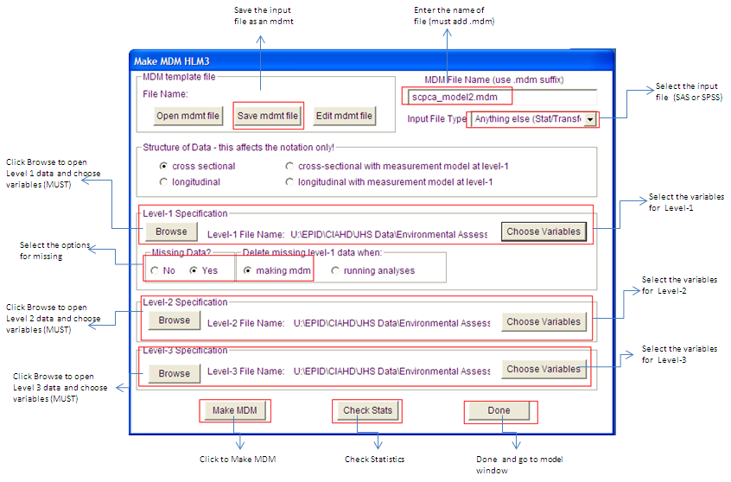

Figure 1: Windows dialogue for making MDM for three-level HLM 2

Step 5 in the “Make MDM HLM3” dialog box do the following:
Step 6: Select input file type: Anything else (Stat/transfer)
Step 7: Enter mdm file name: e.g. scpca_model2.mdm (social cohesion)
Step 8: Browse and find the level 1, level 2, and level 3 SAS files
- Under Level-1 Specification, click Browse then choose the location and file “jhs_sc.sas7bdat.sas7bdat” (or other survey type) then click Open.
- Under “Missing Data”, choose Yes.
- Under “Delete data when”, choose Running analyses.
- Click “Choose Variables” and Choose “ID” (or other ID indicator of person) as L2id, “CTID” as L3id (as census tract ID), and “SC” (i.e,: the scale you want to make) as in MDM then click OK.
- Under Level-2 Specification, click Browse then choose the location and file “jhs_sc_level2.sas7bdat” (or other survey type) then click Open.
- Click “Choose Variables” and Choose “CTID” (or other ID indicator) as L2id, “CTID” as L3id, and “AGE and GENDER” as in MDM.
- Under Level-3 Specification, click Browse then choose the location and file “jhs_sc_level3.sas7bdat” (or other survey type) then click Open.
- Click “Choose Variables” and Choose “CTID” as L3id and both SES indicators (Factor1 and Factor2) as in MDM.

Step 9: Save the input file into MDMT file as scpca.MDMT
Step 10: Make MDM
Step11-12: Check Stats→ Done
Step 13: The next menu screen will emerge that allows you to specify the models for analyses

Step 14: In the model window, to create Model 1 (unconditional) do the following:
- Under Level-1, click “SC” (ie: the scale you are creating) and choose outcome variable.
- Under Level-2, click “AGE” and add as grand mean centered. Click “GENDER” and add as grand mean centered.
- Under Level-3 Since this is unconditional, there will be no adjustment variables in the model.
- Under “Basic Settings”, Distribution should be “Normal”. Change the name of the Output file name to the location/”scpca_model1.txt”. Click “Level-3 Residual File”, choose all the state indicators and choose SAS as the Residual File Type. Change the name to scpca_model1_resid3.sas”. Then click Ok. Then click OK.
- Under “Other Settings”, choose “Iteration control”. Change the number of iterations to 1000. Click ok.
- Under “File”, choose “Save As” and find the location and name the file “scpca_model1.hlm” then click Save.
- Click “Run Analysis (see Figure 2 for how the model should look like before you Run Analysis)”.

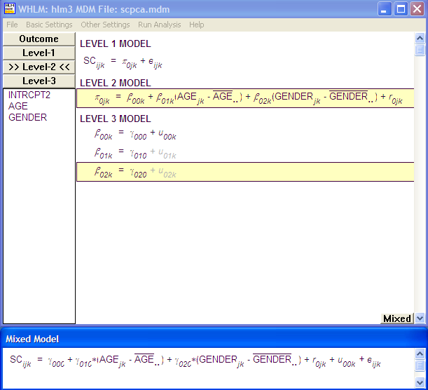

Figure 2: Model 2- adjusted for age (grand centered), gender (grand centered).

Step 8: Find the directory that your residual file (‘scpca_model1_resid3.sas”) was output to and use SAS to create the unconditional empirical Bayes estimates.
Before running this SAS file “scpca_model1_resid3.sas”, open the file and do the following:
- Delete the “libname” line (the first line).
- Change the dataset name in the data line to “scpca_model1_resid3”

Step 9: Using SAS you can use the variables in that file to create the unconditional empirical Bayes estimate (UEBE)
Step 10: SCPCA_UEBE=EB00+FV00 where EB00 is the random deviation or residual and FV00 is the grand mean of the level three intercept. (Refer to SAS code created by Samson Gebreab how to do the calculations - creating_jhs_nb_empirical_estimates_121612.sas)

Step 11: For Conditional Empirical Bayes estimates do the following in the model window,

- Under Level-1, click “SC” (ie: the scale you are creating) and choose outcome variable.
- Under Level-2, click “AGE” and add as grand mean centered. Click “GENDER” and add as grand mean centered.
- Under Level-3, choose, click “Factor1” and add as grand mean centered. Click “Factor2” and add as grand mean centered.
- Under “Basic Settings”, Distribution should be “Normal”. Change the name of the Output file name to the location/” scpca _model2.txt”. Click “Level-3 Residual File”, choose Factor1 and Factro2 indicators and choose SAS as the Residual File Type. Change the name to scpca_model2_resid3.sas”. Then click Ok. Then click OK.
- Under “Other Settings”, choose “Iteration control”. Change the number of iterations to 1000. Click ok.
- Under “File”, choose “Save As” and find the location and name the file “scpca _model2.hlm” then click Save.
- Click “Run Analysis” (see Figure 3 for how the model should look like before you Run Analysis).

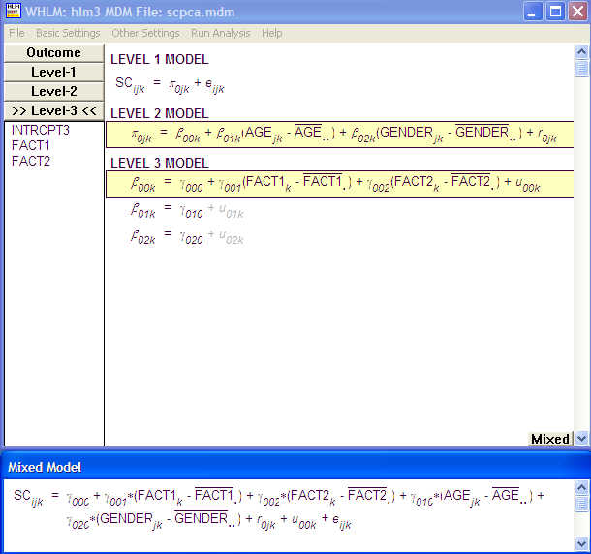
Figure 3: Model 3- adjusted for age (grand centered), gender (grand centered), and factor 1(grand centered), and factor 2 (grand centered)

Step 12: Find the directory that your residual file (‘scpca_model3_resid3.sas”) was output to and use SAS to create the conditional empirical Bayes estimates.
Before running this SAS file “scpca_model3_resid3.sas”, open the file and do the following:
- Delete the “libname” line (the first line).
- Change the dataset name in the data line to “scpca_model3_resid3”
Step 13: Using SAS you can use the variables in that file to create the conditional empirical Bayes estimate (CEBE)
Step 14: SCPCA_CEBE=EB00+FV00 where EB00 is the random deviation or residual and FV00 is the grand mean of the level three intercept. (Refer to SAS code created by Samson Gebreab how to do the calculations- creating_jhs_nb_empirical_estimates_121612.sas)

Steps for calculating spatial empirical Bayes estimates (SEBE)
The first step for calculating spatial empirical Bayes (SEBE) estimates is to create a spatial dependence matrix file using ArcGIS and R software. This is because calculating SEBE requires the spatial contiguity matrix. This information allows HLM spatial weight matrix, W, which is a binary contiguity matrix indicating that census tracts are contiguous to each other. The file contains the first to 12th adjoining neighborhoods, if any and followed by cluster (see the JHS “ jhs_spatial dependence_matrix.rtf” how the input file for creating spatial dependence matrix looks like).
Creating Spatial Dependence Matrix File for HLM input
Step 1: Select the census tracts that have neighborhood survey information. For JHS, extract those unique census tracts ids with neighborhood survey information and export this file as dBASE (*.dbf) file.
Step 2: Import the *.dbf file with census tracts information to ArcGIS
Step 3: Download 2000 census tract shapefiles for state of Mississippi and other states (for these who moved and conducted their neighborhood survey outside Mississippi) from census bureau (https://www.census.gov/geo/www/cob/tr2000.html) and merge this 2000 census tract shape file with *.dbf file (Step 2) in ArcMap to create a JHS neighborhood survey census tract shape file.
Step 4: Use an R code (“R code for creating spatial dependence matrix.txt”) created by Samson Gebreab to import the neighborhood survey census tract shape file into R software. In addition, this R code will also help create the spatial contiguity matrix (“Rook or “Queen”). The R code also format the spatial contiguity matrix in table form for use in HLM. Finally, Exports the file into comma-separated values (CSV) file where you can import into SAS and merge with the rest of input file for analyses in HLM.
Calculating spatial empirical Bayes estimates using HLM

Step 1: Open and run the SAS program to create the proper data set for calculating spatial empirical Bayes estimates (SEBE). SEBE is implemented within two levels of HLM framework (HLM2). However, we need to create three files: These files are: 1. Person level file (includes person level crude mean, age and gender), 2. Census tract level (includes census tract ID and other variables). You need to create these two files as SPSS file for each scale and save the datasets to the appropriate folder (refer- jhs_nbscales_datasetup_082312.sas). In addition to these two files, an additional third dataset is required for SEBE calculation. This third file is called “Spatial Dependence Matrix file”. You will create this file using R code and formatted to and formatted to SPSS file (see the steps for creating this file below).

Step 2: Open HLM software
Step 3: Go to File→ Make MDM →Stat package input
Step 4: Select HLM type: HLM2 and click OK
Step 5: Select input file type: SPSS/Windows
Step 6: Enter mdm file name: e.g. scpcasp.mdm (social cohesion PCA based spatial)
Step 7: Browse and find the level 1, level 2, and Spatial Dependence matrix SPSS files (shown in Figure 1).

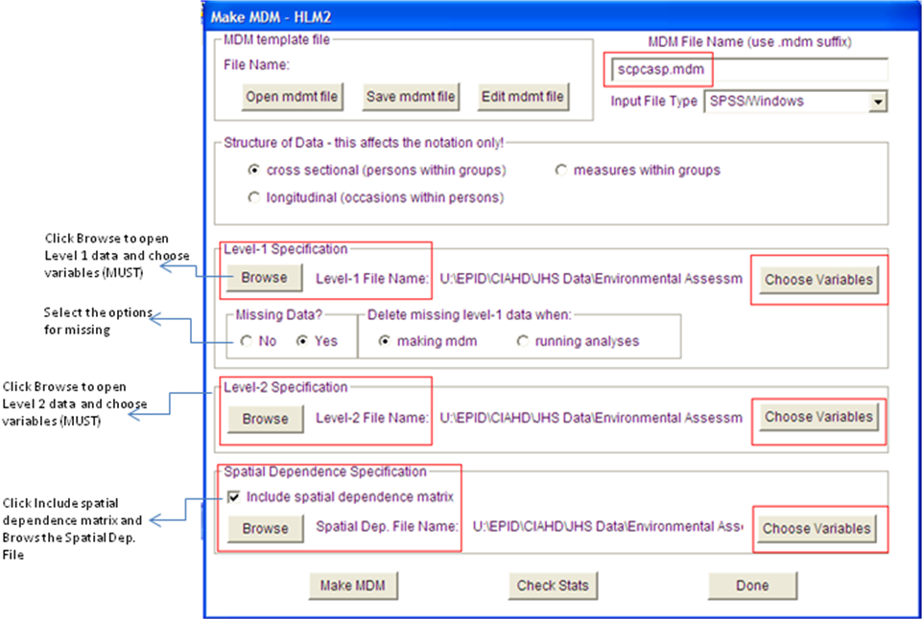

Figure 4: Windows dialogue for making MDM for 2-level HLM 2 with Spatial Dependence Specification.

Under Level-1 Specification,
- Click Browse then choose the location and file “scpcamean.sav” (or other survey type) then click Open.
- Under “Missing Data”, choose Yes.
- Under “Delete data when”, choose Running analyses.
- Click “Choose Variables” SCPCRAW (individual crude means), age, gender and Choose “CTID” (or other ID indicator) as id then click OK.

Under Level-2 Specification,
- Click Browse then choose the location and file “jhs_scpca_level3.sav” (or other survey type) then click Open.
- Click “Choose Variables” and Choose “CTID” (or other ID indicator) as id

Under Spatial Dependence Specification,
- Click “Include spatial dependence matrix”. This will activate the Browse for the “Spatial Dep. File Name:
- Click browse Spatial Dep. File Name then choose the location and file “JHS_NB2.sav” then click Open. This file JHS_NB2.sav is prepared in R and formatted into SPSS file (For detail information how to create this file is see the steps for creating “ Spatial Dependence Matrix File”)
- Click “Choose Variables (N1 – N2, Count)” as SD var and Choose “CTID” as id as shown in the figure.

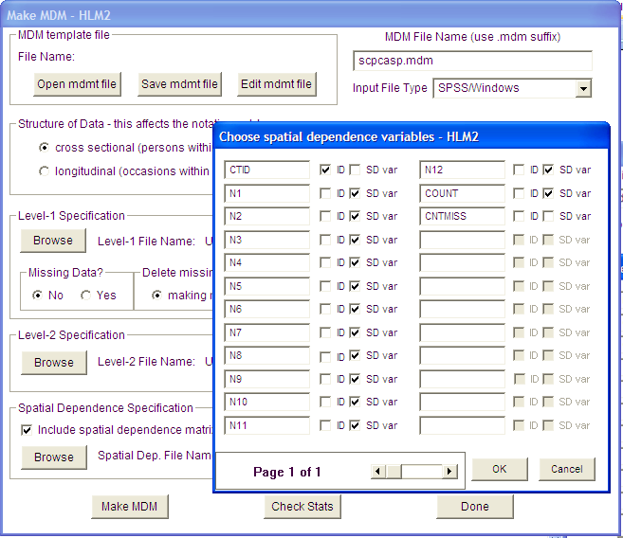

Figure 5: Windows dialogue for choosing variables from spatial dependence matrix file.

Step 8: Save the input file into MDMT file as scpcasp.mdmt
Step 9: Make MDM
Step10-11: Check Stats→ Done
Step 10: The next menu screen will emerge that allows you to specify analyses

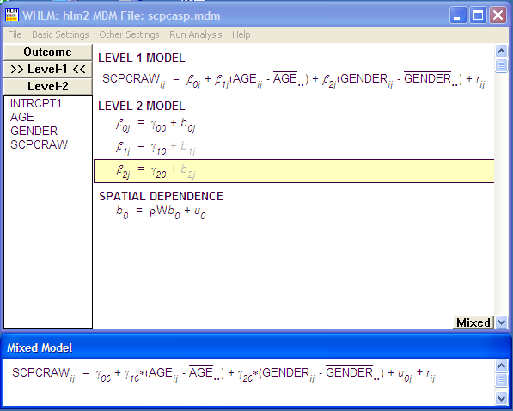
Figure 6: Model 4 (spatial model) - adjusting for age and gender and accounting for Spatial dependence.

Step 11: In the model window, to create spatial model do the following:
- Under Level-1, click “SCPCRAW” (i.e., the scale you are creating) and choose outcome variable and, click “AGE” and add as grand mean centered. Click “GENDER” and add as grand mean centered.
- Under Level-2 Since this is Spatial, there will be no adjustment variables in the model.
- Under “Basic Settings”, Distribution should be “Normal”. Change the name of the Output file name to the location/” scpca_spatial.txt”. Click “Level-2 Residual File”, choose level 2 indicators and choose SAS as the Residual File Type. Change the name to scpca_spatial_resid3.sas”. Then click Ok. Then click OK.
- Under “Other Settings-HLM2”, choose “Iteration control”. Change the number of iterations to 1000. Click ok.
- Under “Estimation Settings-HLM2”, choose “Run as spatial dependence model”. Click ok.
This will add the spatial dependence model: to the model window.
- Under “File”, choose “Save As” and find the location and name the file “scpca_spatial.hlm” then click Save.
- Click “Run Analysis”.

Step 12: Find the directory that your residual file (“scpca_spatial_resid3.sas”) was output to and use this SAS file to create the spatial empirical Bayes estimates.

Before running this SAS file “scpca_spatial_resid3.sas”, open the file and do the following:
- Delete the “libname” line (the first line).
- Change the dataset name in the data line to “scpca_spatial_resid3”

Step 13: Using SAS you can use the variables in that file to create the spatial empirical Bayes estimate (SEBE)
Step 14 SCPCA_SEBE=B_INTRCP + FVINTRCP where B_INTRCP is the random deviation with spatial dependence and FVINTRCP is the grand mean of the level 2 intercept. (Refer to

